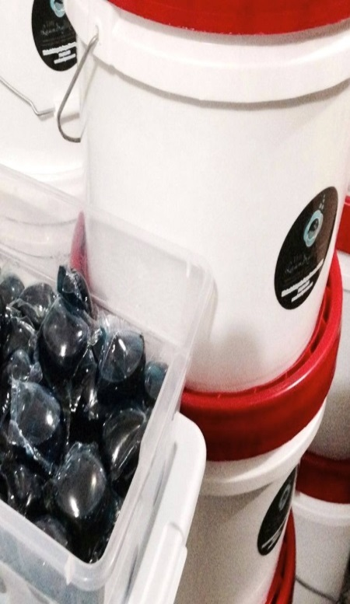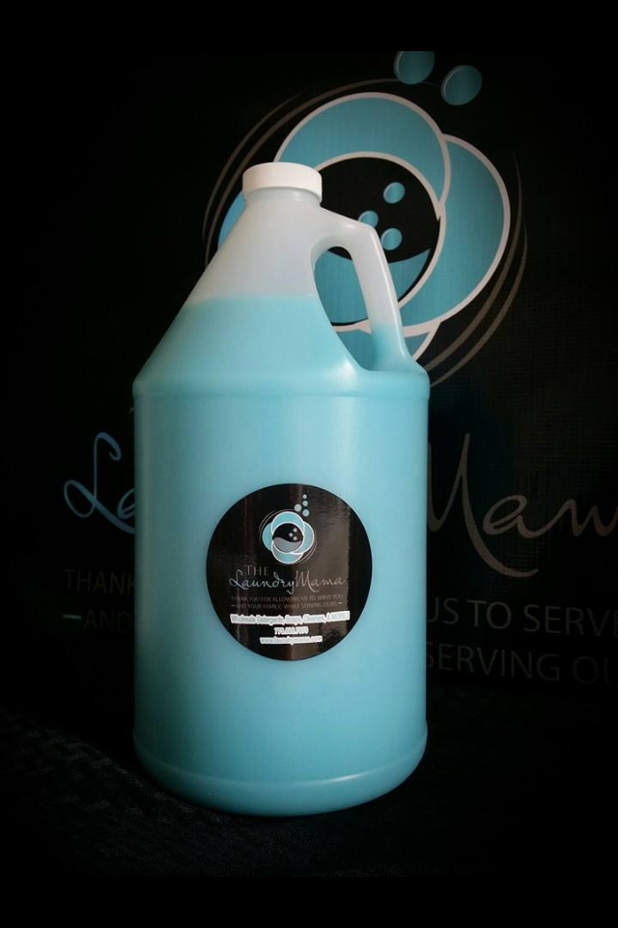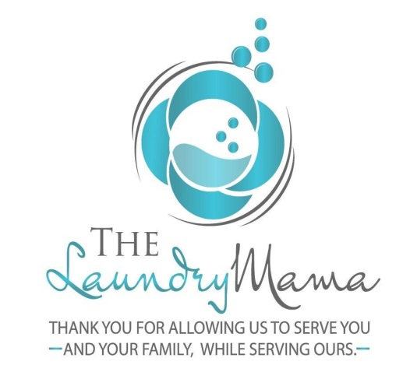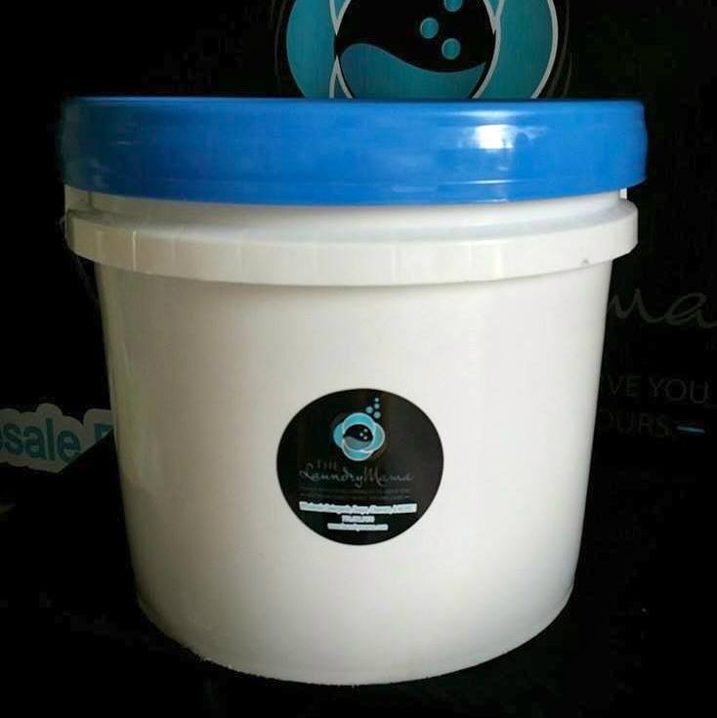

**The Laundry Mama Fundraising Advantage**

What sets this fundraiser apart from all the others is you are maximizing your profit by selling items **EVERY** household **NEEDS** while actually still **SAVING** your supporters household money. So what that means to you is no more doughnuts, candy, t-shirts, savings cards, cookies, candles, sodas, raffles, or car washes!

Kristin Petite

478-234-0328

lmfundraiser@yahoo.com

[www.facebook.com/laundrymamaaugusta](http://www.facebook.com/laundrymamaaugusta)

[www.facebook.com/laundrymamasavannah](http://www.facebook.com/laundrymamasavannah)

[www.facebook.com/laundrymamamcdonough](http://www.facebook.com/laundrymamamcdonough)

We are Kristin and Billy Petite and we are excited about offering you what has been voted the #1 fundraiser for the second year in a row. We are your Laundry Mama Inc. distributors and parents of kids in the Putnam County, Georgia School system where they participate in numerous extracurricular activities. We are tired of saving cards, candles, cookies, t-shirts, sodas and car washes with minimal returns, are you? Please look at the numbers as they are very real and very recent. Call the coaches and directors who have used this fundraiser and decide when you are ready to get started.

What we offer your team are the actual laundry and cleaning products you would go to a big box store like Wal-Mart or Kroger to purchase. Our items are not watered down and they are not homemade. All items come directly to our warehouse directly from the manufacturer.

Have you ever heard of a laundry detergent fundraiser? It is a good thing that you have not and makes this opportunity even better for your team or organization!

A middle school profited $31,000 after selling 1658 units of product with 178 participants while another middle school with 236 participants that sold 2456 units profited $46,579. A soccer team with 27 participants sold 649 units profiting over $12,000 while a high school baseball team made $11,000 selling 605 units. The gymnastic team of only 6 with World Xtreme Vipers profited $2,500 after only a two week sale.

Fannin County High generated a profit of $12,690 while Union Grove Softball made a first time profit of $1,461.

Ola High School Football Booster Club profited nearly $6,000 doing a two week sale during the off season with only half of the team participating.

Putnam County High School Football team has profited $8,000 with only 15 kids participating, while The Thomas Jefferson Academy PTO was excited about profiting $11,000.

East Laurens Cheer made a huge profit of $4,736, while North Oconee Cheer is showing a great profit of $2,400.

The Mid Ga Rebels basketball team showed a profit of $2,500 with only 5 members selling items. These numbers are real, verifiable, recent, and reachable by your organization! These are only a few of the very recent sales so when will we be able to add your team or organization to this list.

There is no reimbursement and you do not have to wait weeks for your profits to be available. Your profit is available for your use immediately following the close of the sale, even prior to delivery! Your group collects payment upon order and the only funds received by The Laundry Mama, Inc is the actual cost and delivery/shipping fee.

A reference sheet is included in this packet for your use, please use it and contact the fundraising coordinators as there have been no complaints reported and only re orders for product coming in to us on our Facebook sites. Not only are the supporters ordering more products, but the coordinators are eagerly awaiting the next round of fundraising!

How do we get our product is one of the most frequently asked questions along with how do we sell it so “cheap”. We purchase our supply directly from the manufacturer of the premium products wholesale in large bulk containers so therefore the only difference between the product we deliver and the product you would purchase at your local store is the packaging and of course the price. We are the only insured distributor with an actual contract purchasing directly from the manufacturer in the southeast.

The vast majority of all schools do not use this fundraiser only once as most repeat every 3 months. The savings and quality of the product for the supporter is so tremendous that they wish to re purchase when their supply runs out. Most 3.5 gallon buckets or 125 ct pods last the average family 3 months allowing this sale to be ran year round.



The savings on the detergent are remarkable and real! The average price to purchase 1 gallon of Tide Original is $18.99 for a total of $67.00. Save your organizations supporter over $28.00 while they fund your group. For Gain Original the average price per gallon is $16.99 saving your supporter over $21.00. By purchasing the Arm and Hammer Free and Clear your supporter will save over $29.00 while supporting your organization. By purchasing the detergent or dishwashing pods the supporter is saving on average $15.00 per item.

The Dawn and Downy are priced in line with the big box stores in any ones area. If the product is available at a lower price in your region the sell price can be adjusted, but ask the references provided and you will find out quickly that due to the savings on the detergent there has not been a loss of end profit. What other fundraiser can you save your supporter money while turning over a serious profit?

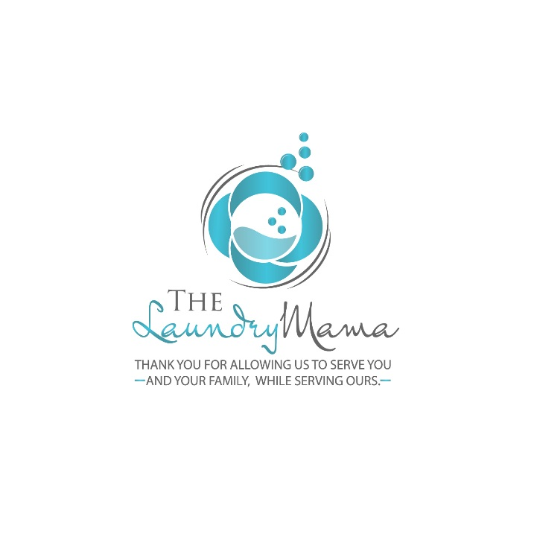THE LAUNDRY MAMA, INC. FUNDRAISERS

WHOLESALE DETERGENTS, SOAPS, CLEANERS, AND MORE!

THE EASIEST, MOST PROFITABLE, AND BEST FUNDRAISER YOU WILL EVER DO - GUARANTEED!

**YOUR ORGANIZATION PROFITS:**

$18 per laundry detergent sold   
$7 per gallon of dish soap or softener sold  
$18 per auto dishwasher pods sold

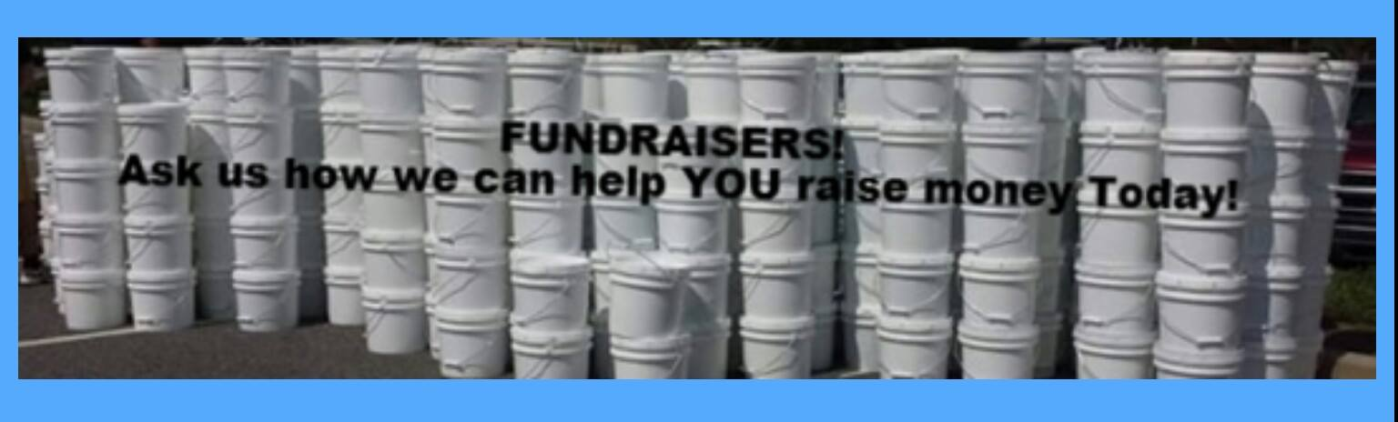

Our liquid detergents come in 3.5 gallon buckets and are available in Tide and Gain original scent, Arm and Hammer free and clear which is dye and perfume free.

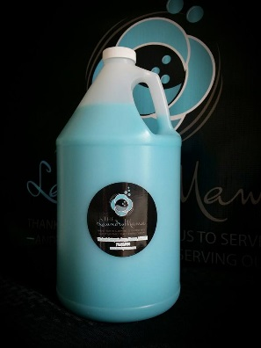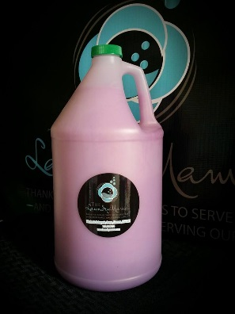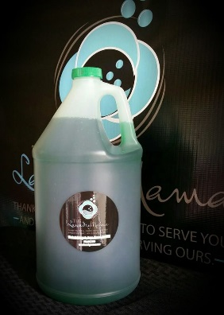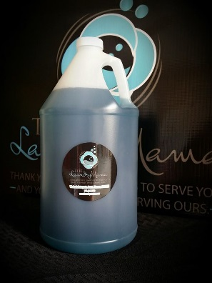

Fabric Softener in Downy April Fresh type and Lavender in one gallon jugs. Dish soap available in Dawn original blue and green apple antibacterial in one gallon jugs.

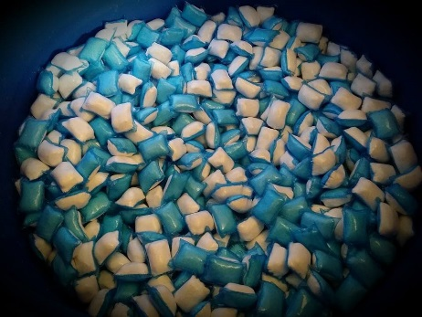 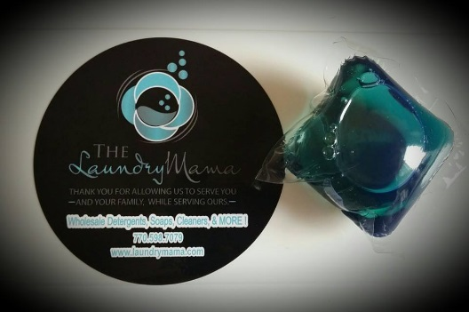

We offer dishwasher pods and detergent pods. Our detergent pods are Tide original scent and have fabric softener and stain remover inside of them. The dishwasher pods are Cascade pods.

**OUR PRODUCT INFO:** Our products are the premium Major Name Brands. We buy in large bulk direct from the manufacturer and then repackage the products into small containers (buckets and 1 gallon jugs) to sell to you. All of our products are better than any “generic” you would find at the store as it is formulated for the wholesale market and made to save you money. They all contain optimal brighteners and only the best ingredients. Don’t take our word for it go, please check out our reviews on our main Laundry Mama Facebook page. We are the largest wholesale detergent distributor in the southeast.

** All of our products are HE formulated and work in every machine.

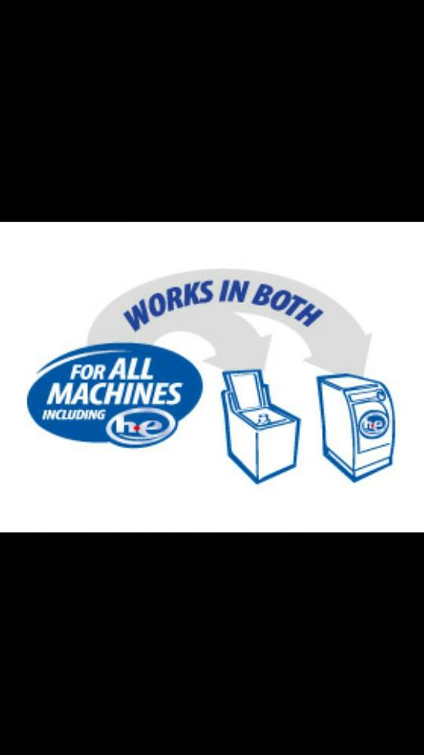

**READY TO GET STARTED?** - Just email us at lmfundraiser@yahoo.com or call Kristin with your organization name, address, and info along with the dates you'll be running your fundraiser.

**DELIVERY** - Collect your orders and once complete, email us the totals for each product. We will tally your order, email you an invoice with directions on how to make payment. Payment is due upon order and it must be certified funds or cash. A school or organizational check must post prior to processing an order. W-9 is available upon request. We can deliver your order within 21 days of receipt of your deposit, anywhere within the continental United States. Email us today to get started!

Delivery fees are 5% of your cost for any orders over $5000 and $200 for any orders less than $5000

[www.facebook.com/LaundryMamaSavannah](http://www.facebook.com/LaundryMamaSavannah)

www.facebook.com/LaundryMamaMcdonough  
[www.facebook.com/LaundryMamaAugusta](http://www.facebook.com/LaundryMamaAugusta)

lmfundraiser@yahoo.com  
478-234-0328

**The Laundry Mama, Inc.**

**Recent Fundraising References:**

**Cammie Dalley**

**Cammiedalley@lcboe.net**

**Kyle Gourley @ Putnam County High School**

**706-485-9971**

**Brad @ Ola Booster Club**

**770-616-9563**

**Andrea Stephens @ Mid Ga Rebels**

[**ans61@hotmail.com**](mailto:ans61@hotmail.com)

**Chantay Sammons @ Thomas Jefferson Academy PTO**

**taytoys@hotmail.com**

**Ashley Downs @ North Oconee County Cheer**

**adowns@oconeeschools.org**

**Kristin and Billy Petite**

**478-234-0328**

**478-234-0323**

**lmfundraiser@yahoo.com**