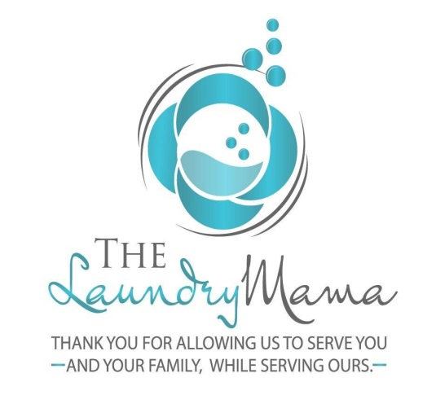
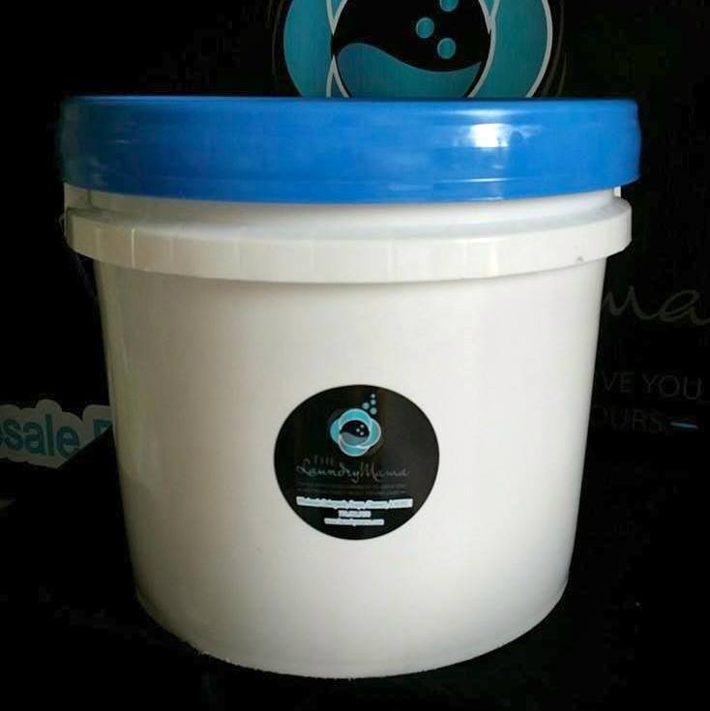
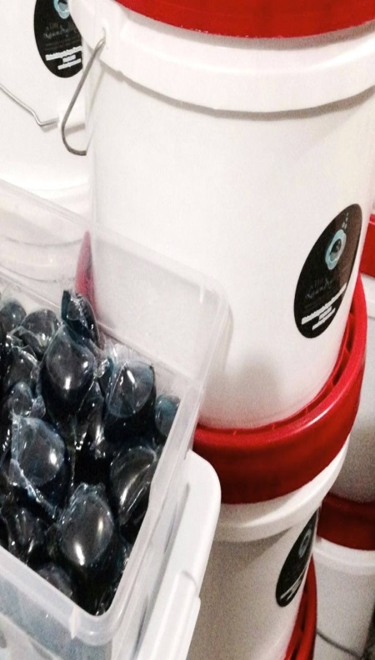
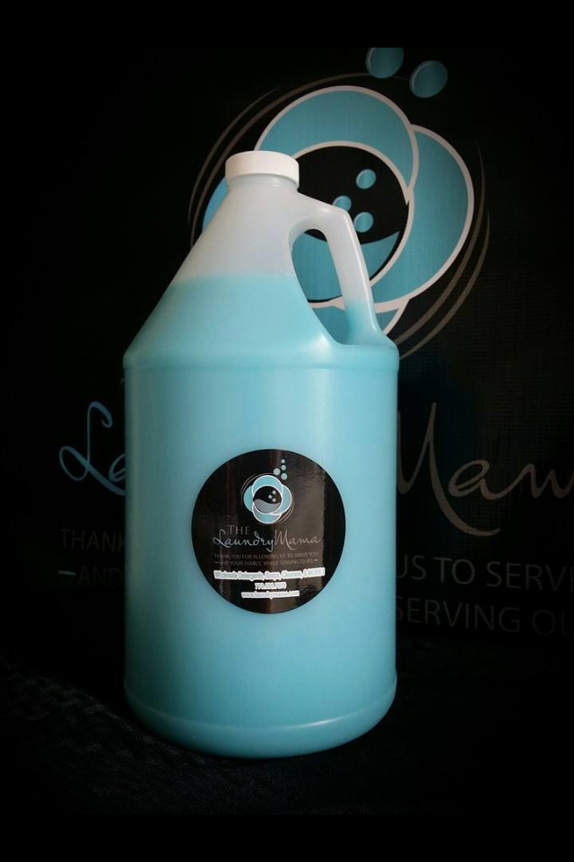

Your Liquid Detergent will be delivered in 3.5 gallon buckets.
The Dish soap and Fabric Softener will be delivered in 1 gallon containers.
Pods will be in easy to use plastic container for your convenience.
Please don’t forget to purchase your pumps for $6 each, they will go on top of the containers.
Thank you for supporting our fundraising efforts!

